Nepal College of Information Technology
Balkumari Lalitpur
Assessment Exam Fall Semester 2008
Year: II Sem: I
Program: B.E Time: 3hrs
FM: 100 PM: 50

Engineering Math-III

1. a. Write any four properties of determinant.
Show that 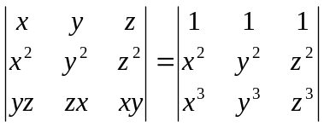= (y-z) (z-x) (x-y) (yz + zx + xy) 2+6
b. Shot that the necessary and sufficient condition for a square matrix A to possess inverse is that |A| 0. 7
OR
If A and B are two matrices of specified order, Show that (AB)^{t} = B^{t}A^{t}
2. a. Solve by Gauss elimination method: 8
2w - 2x + 4y = 0
-3w + 3x -6y + 5z = 15
w - x + 2y = 0
b. Define rank of the matrix. Find the rank of 1+6
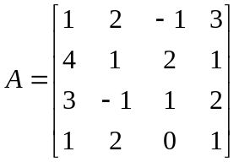
3. a. Find the eigen value and eigen vector of the marix
A = 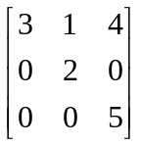
b. Find the fourier series of a function f(x) = 1-x² for -1<x<1 7
4. a. Find the fourier series of f(x) = |x| for and show that 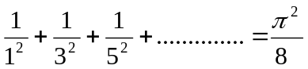 8
b. State whether the given function is even, odd or neither even nor odd & find its fourier series
f(x) = 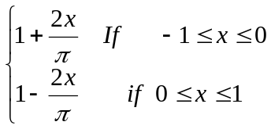 7
5 a. A particle moves along the curve x = t³ +1, y = t², z = 2t + 5. Find the components of its velocity and acceleration at t = 1 in the direction 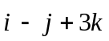 8
b. Find the angle between the surface x² + y² + z² = 9 and z = x² + y² - 3 at the point (2, -1, 2) 7
6. a. Calculate 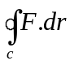 if 7
b. Using Green's theorem, evaluate the integral 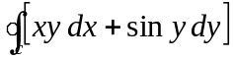 where C is the triangle with vertices (1, 1) (2, 2), (3, 0) counterclockwise. 8
OR
Show that the value under integral sign 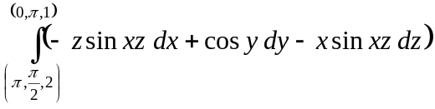 is exact and evaluate the integral.
7. Write short notes on: 2*5
i. Consistency and Inconsistency in a system of linear equation.
ii. Eigen value and eigen vector.
iii. Even and odd function.
iv. Curl, divergence and gradient
v. Directional derivative.

